Antiseptic Cap or Disinfecting Cap

What is an antiseptic cap or disinfecting cap?

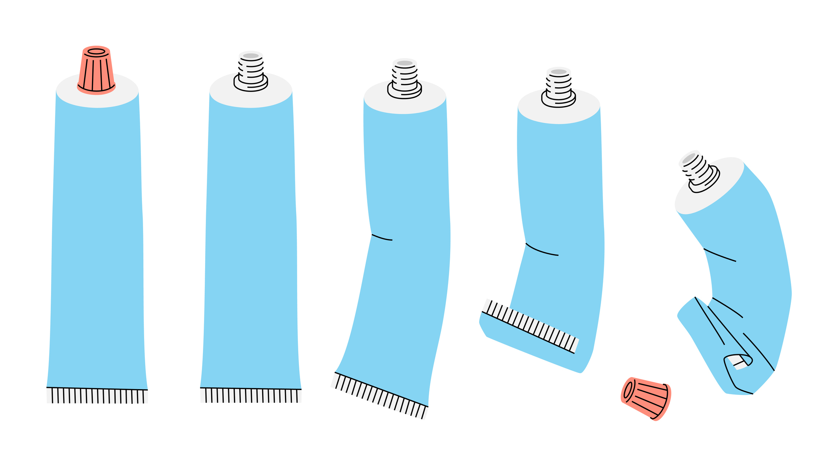An antiseptic cap, also known as a disinfecting cap, an antiseptic-containing hub, an antiseptic connector cap, or an antiseptic-containing port protector, is a cap that goes on the end of a needleless connector and provides antisepsis to continually disinfect the needleless connector. Antiseptic caps allow for passive disinfection with isopropyl alcohol or iodinated alcohol. In acute care hospitals, antiseptic caps have been associated with lower rates of central line-associated bloodstream infections (CLABSIs)1

Who should use an antiseptic cap or disinfecting cap?

Acute care CLABSI prevention guidelines recommend using antiseptic caps to cover connectors if other implemented strategies are insufficient for decreasing CLABSIs2. In home infusion settings, antiseptic caps may be most helpful in highest-risk patients. Consider which of your patients may be considered high risk. Examples of high-risk groups may include patients with recurrent CLABSIs, patients on home parenteral nutrition, also known as central parenteral nutrition or total parenteral nutrition (HPN, CPN, or TPN), pediatric patients receiving chemotherapy, or other identified high-risk groups. Manual disinfection alone (without an antiseptic cap) is considered an acceptable approach in most patient populations2). Because data show reduced bacterial decontamination with manual disinfection (scrub the hub) when compared with antiseptic caps3 , you may wish to continue using manual disinfection even when an antiseptic cap is used.

How should you use an antiseptic cap or disinfecting cap? 4, 5

Manufacturer instructions may vary, so be sure to read and follow the instructions carefully. If you choose to use an antiseptic cap in an individual patient, make sure the disinfecting cap is used consistently and following manufacturer instructions. Scrub the hub of the needleless connector with an alcohol swab for 15 seconds prior to inserting the antiseptic cap. The antiseptic cap typically will be ready for use after 30 seconds. The antiseptic cap should be replaced weekly. Once the antiseptic cap is removed, discard the antiseptic cap and do not reattach it to a needleless connector.

***Reference***

1. Beeler C, Kerley D, Davis C, et al. Strategies for the successful implementation of disinfecting port protectors to  reduce CLABSI in a large tertiary care teaching hospital. *Am J Infect Control*. 2019;47(12):1505-1507. doi:10.1016/j.ajic.2019.05.016

2. Buetti N, Marschall J, Drees M, et al. Strategies to prevent central line-associated bloodstream infections in acute-care hospitals: 2022 Update. *Infect Control Hosp Epidemiol*. 2022;43(5):553-569. doi:10.1017/ice.2022.87

3. Roberts SC, Hendrix CA 2nd, Edwards LM, Feinn RS, Martinello RA, Murray TS. A mixed-methods evaluation on the efficacy and perceptions of needleless  connector disinfectants. *Infect Control Hosp Epidemiol*. 2023;44(2):230-233. doi:10.1017/ice.2022.72

4. Barnes S, Olmsted R, Monsees E, Harris JE, Khoury R, Hadaway L. *APIC Implementation Guideline*. 1st ed. Association for Professionals in Infection Control and Epidemiology; 2015. <https://apic.org/Resource_/TinyMceFileManager/2015/APIC_CLABSI_WEB.pdf>

5. Gorski LA, Hadaway L, Hagle ME, et al. Infusion Therapy Standards of Practice, 8th Edition. *Journal of Infusion Nursing*. 2021;44(1S). https://journals.lww.com/journalofinfusionnursing/Fulltext/2021/01001/Infusion_Therapy_Standards_of_Practice,_8th.1.aspx